Southfields Primary School

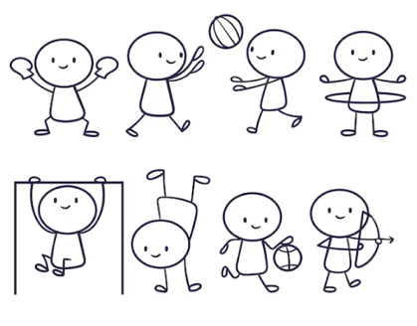

Sports funding 2022-23
Southfields Primary School PE and Sport Premium Strategy

Overview of Southfields Primary School’s strategies for improving pupils’ PE and sport participation and attainment and giving pupils the opportunity to develop a healthy, active lifestyle

Purpose of the premium
The Sports Premium must be used to fund additional and sustainable improvements to the provision of PE and sport, for the benefit of primary-aged pupils to encourage the development of healthy, active lifestyles.
We must use the funding to make additional and sustainable improvements to the quality of the PE, sport and physical activity they provide (As outlined in the most recent DFE guidance)
This means we use the PE and sport premium to:
- build capacity and capability within the school to ensure that improvements made now are sustainable and will benefit pupils joining the school in future years
- develop or add to the PE, sport and physical activity that your school provides

Key indicators
PE and sport premium will be used to secure improvements following these 5 key indicators:
- Increased confidence, knowledge and skills of all staff in teaching PE and sport
- Engagement of all pupils in regular physical activity
- The profile of PE and sport is raised across the school as is also used as a tool for whole school improvement
- Broader experience of a range of sports and physical activities offered to all pupils
- Increased participation in competitive sport
We would not use the money to:
- employing coaches or specialist teachers to cover planning preparation and assessment (PPA) arrangements - these come out of schools’ core staffing budgets
- build up time to reach the minimum requirements of the existing PE curriculum.

Overview of Southfields Primary School’s Vision and Aims

The funding allows us further opportunities – ‘Going the extra mile’

We study other sporting people and learn from their views. Please read a few below:

“You can’t control what people say about you and what they think about you. You can’t plan for bad luck. You can only work your hardest and do your best and tell the truth. In the end, it’s the effort that matters. The rest is beyond your control.”
- Maria Sharapova
Skilled tennis player Maria Sharapova is the only Russian player to have won the Grand Slam, meaning she won all four major championships in the same year.
“We all have dreams. But in order to make dreams come into reality, it takes an awful lot of determination, dedication, self-discipline, and effort.”
- Jesse Owens
Famous for winning four gold medals at the Olympics of 1936 and setting multiple world records despite experiencing extreme racism, Owens truly made history.
“Impossible is not a fact. It’s an opinion. Impossible is not a declaration. It’s a dare. Impossible is potential. Impossible is temporary. Impossible is nothing.”
Muhammad Ali. Muhammad Ali was a heavyweight boxer and is considered by many to be the greatest boxer of all time - no wonder so many of his quotes are well remembered.
“If you don’t have massive dreams, you might as well stay in bed”
Sonny Bill Williams
New Zealander Sonny Bill’s career has been an amazing one, playing for rugby teams including the New Zealand national team before moving into professional boxing.
“Sport has literally changed my life. I’m here because of sport. It has given me a lot of confidence, a lot of courage, and a lot of discipline. It’s helped me to be the person that I’ve grown to be today.”
- Serena Williams
One of the world’s most well-known tennis stars, Serena Williams and her sister Venus have both been incredibly successful in the sport. Serena has won twenty-three Grand Slam titles, as well as Olympic gold medals.
“A successful competition for me is always going out there and putting 100 percent into whatever I’m doing. It’s not always winning ... People, I think, mistake that it’s just winning. Sometimes it could be, but for me, it’s hitting the best sets I can, gaining confidence and having a good time and having fun.”
- Simone Biles
Simone Biles is an American gymnast who has won an incredible 7 Olympic titles and is known for her fun, enthusiastic routines and great success in the sport.
“Dedication, hard work all the time, and belief.”
- Cristiano Ronaldo
Known for his fast footwork, Ronaldo is an internationally recognised footballer from Portugal. When he’s not playing Manchester United, you won’t find him putting his feet up - he also captains the Portuguese national team.

“ALL pupils leaving primary school to be physically literate and with the knowledge, skills and motivation necessary to equip them for a healthy, active lifestyle and lifelong participation in physical activity and sport.”

DfE

“Physical Literacy can be described as the motivation, confidence, physical competence, knowledge and understanding that provides children with the movement foundation for lifelong participation in physical activity be physically literate supports their development as competent, confident and healthy movers.” ‘

Primary School Physical Literacy Framework, developed by Youth Sport Trust, Sport England, County Sport Partnership Network, Association of Physical Education and Sports Coach UK.

Financial Year
2022 –2023
Total PE academic year  2022 -23 | Sports funding  ( 5/12 and 7/12 financial year budgets to allocate academic year 2022-23 spending)  October 2022 - £12,378  April 2023 - £8,842 | £21,220

How the improvements made will be sustainable in the future:

- Increased confidence, knowledge and skills of all staff members
- Improve engagement of all pupils in regular physical activities
- Raising the profile of sports and also using it to support whole school improvement
- Broader experiences of a range of sports and physical activities offered to the pupils to broaden their horizons
- Continue to build strong links with the local community, to increase participation in competitive sports - this should also include local, regional and national competitions

We will purchase resources and online training through ‘Complete PE’ in PE/Sports to support raising confidence, knowledge and skills. In addition to this we will have termly sporting events in school to promote and encourage pupils to take part in new sports – such as the skipping workshop and also circus school. We will also train staff during enhanced sessions with FA, NFL and other sporting associations.

We will encourage engagement of pupils to take part in regular physical activities by offering exciting lunch times, playtimes and clubs beyond the school day.

We intend to broaden horizons through introducing new sports to the children such as climbing walls, golf and we will also offer a ski trip to France each year. We also run 4 residential visits with active activities for our pupils. We support beyond our own school pool to encourage all year groups to swim in our small pool but also access the deep pool and achieve the 25m and offer catch up sessions for those who need them.

We will take part in local, regional and national competitions as well as support the Majorette pupils in school to take part at a higher level. Further to this the school will teach sports where additional qualifications are required, such as ski leader and vaulting and swimming qualifications. We have an active healthy school committee and we promote events for parents and families to promote healthy life styles.

At Southfields Primary School, the PE and Sports funding is spent in a variety of ways with the direct and explicit aim of making additional and sustainable improvements to the provision of PE and sport for the benefit of all pupils to encourage the development of healthy, active lifestyles.

A breakdown of the 2022-23 expenditure is shown below, together with termly impact evidence of our success in PE, sport and healthy, active lifestyles’.
PE and Sport Improvement Strategy 2022-23 | Amount (£) | Description | Evidenced Impact
Engagement of children in physical activity and water confidence | £3,745 | Deep water swimming pool sessions at local pool. This includes catch up sessions to reach 25m  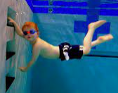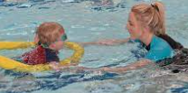 | We have offered swimming to year 4,5 and 6 in deep swimming at a local pool and as a result we have significantly improved our % of pupils who have reached the 25m or better.  In our own pool we support all year groups from EYFS to Year 6 to all swim weekly in the Summer term and use swimming pool organisation certificates and badges for our pupils.  Resuss training staff - £113.80 is also part of this budget.
Broader experiences of a range of sports and physical activities offered to the pupils to broaden their horizons | £2,250 | Support the ski trip to France by supplementing PP/CiC pupils as well as two additional staff on the visit to improve the ratio as we fly and have evening snow activities  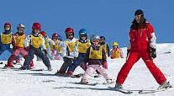 | Pupil and Parent feedback was 100% successful, the families have written to governors to ask for another ski trip. Of the 34 pupils from 7yrs to 11 years who attended- all learnt to ski and by the end of the visit were able to ski a blue and green run. 6 pupils progressed to red and black level.
Enhance staff knowledge and confidence | £250 | Complete PE online resources for supporting staff CPD, training, planning and assessment  AfL and AoL  | The whole school accesses and uses the complete PE resources to support their own professional development as well as improve the quality of PE/sports lessons
Enhance staff knowledge and confidence | £210 | Youth Sport Trust website   | Staff access these online resources to support equality, inclusion and diversity education, governance and co-ordinator and leadership across the school – this also supports our work with our sports pupil ambassadors more recently we have used it for an engagement model
Engagement of children in physical activity | £2000 | Bike-ability (Which is free) is also enhanced by our promotion of bike riding in EYFS with cycle push bikes and bike riding with our youngest pupils. Purchase additional bikes so more pupils can practice the skills they have learnt  We also organise a cycle family bike ride from the school into the middle of Peterborough 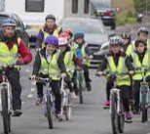 | We have completed the bikeability scheme with the year 6 with a large take up from the pupils which has improved their ability on their bike as well as safety -47 pupils took part in this.  The EYFS bike support is planned for the Summer Term. They improve their Gross and fine motor skills which has an impact on raising standards in writing across the curriculum.  The family bike ride is planned for the Summer Term.
Engagement of children in physical activity and regular swimming to support the 25m bench mark and water confidence | £2,000 | Additional training to allow all pupils to swim in the pool, certificates and badges for pupils to assess ongoing from our youngest pupil’s water confidence and ability in water.  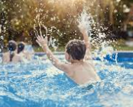 | We open the pool in the Summer Term and all pupils swim this improves their water confidence and supports them achieving their 25m.  This money is used for training, recognition of their efforts as well as supporting heating the pool to allow for more pupils in more year groups to swim.  Purchase additional pool equipment to allow pupils to learn different skills in water
Broader experiences for children and staff knowledge is improved | £1200 | School Colour Run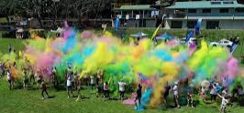 | https://www.ukschoolrun.com/colour-run  Planned for the summer term  80p per pupil for Colour Cloud  £1 per pupil for Colour Run  Health and Safety sheet  https://sites.create-cdn.net/sitefiles/45/2/2/452218/Colour_Powder_Material_Safety_Data_Sheet.pdf
Broader experiences for children and staff knowledge is improved | £715  Child golf clubs in bag - £20 x 20 = £400  Visit to Pitch and Putt – year 3  90 x £3.50 + £315 | Mini Golf Course and visit to pitch and putt  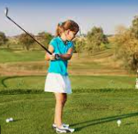 | Golf Equipment purchased and pupils using this during interventions and break and lunch times.  Planned visit in the summer term for Pitch and Putt year 5
Continue to build strong links with the local community, to increase participation in competitive sports - this should also include local, regional and national competitions | £300 | Community Sports Day Event – try different sports with families  Year 6 pupils to lead this as sports ambassadors  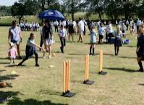 | We have invited a range of professionals and people who are involved in sports as well as our own school community to take part in promoting sports in the community  - Summer Term 2023  - Future Boxing  - Majorettes  - FA  - NFL  - Martial Arts  - Gymnastics  - Toddler Swimming demonstrations  - Cricket  - Bowling  - Bikes/Cycling clubs  - Walking clubs  - Adult and Child Dance classes
Broader experiences for children and staff knowledge is improved | £240 | County dancing club and regional event to support pupils and the local community 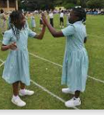 | Summer Term update
Broader experiences for children and staff knowledge is improved. Raising the profile of sports and also using it to support whole school improvement | £7,185 | Youth dreams  - Support to enhance pupils’ experiences within the school day  - ECT training  - Staff training  - Team teaching  - Coaching  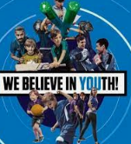 | The pupils have been more active, learnt more games and had more support to improve their ability in PE and Sports with professional coaches and training.  Staff including teachers, ECTs and TAs have been supported with Team Teaching, coaching and bespoke lesson support and CPD.  Impact has been very good as reported by staff and children
Raising the profile of sports and also using it to support whole school improvement – behaviour therapy | £1,125 | Oak Academy  Support for Behaviour through sports of our children with Boxhall profiles | Pupils behaviour has improved through the use of sports therapy and bespoke programmes to support pupil’s ability to improve whole school behaviour expectations
Total Expenditure | £21,220

Sustainability
- Items that are ordered are tried to be done in bulk to save deliveries and postage.
- The use of CPD will help staff to be confident teaching PE once the funding is not available anymore.
- The maintenance of the pool and pool equipment will allow staff and children to continue to use the pool for academic years in the future.
- School events will inspire children to take up more physical activity and try different sports.
- Buying equipment that is durable and long lasting will help us to build stock that can be used in years to come when the funding may be withdrawn.
- Where items are purchased, we will try to use eco-friendly materials that support the work of our healthy schools.
- We hope that the legacy of the sports funding will support our pupils and community in the future with healthy minds and lives.

