Southfields Primary
School
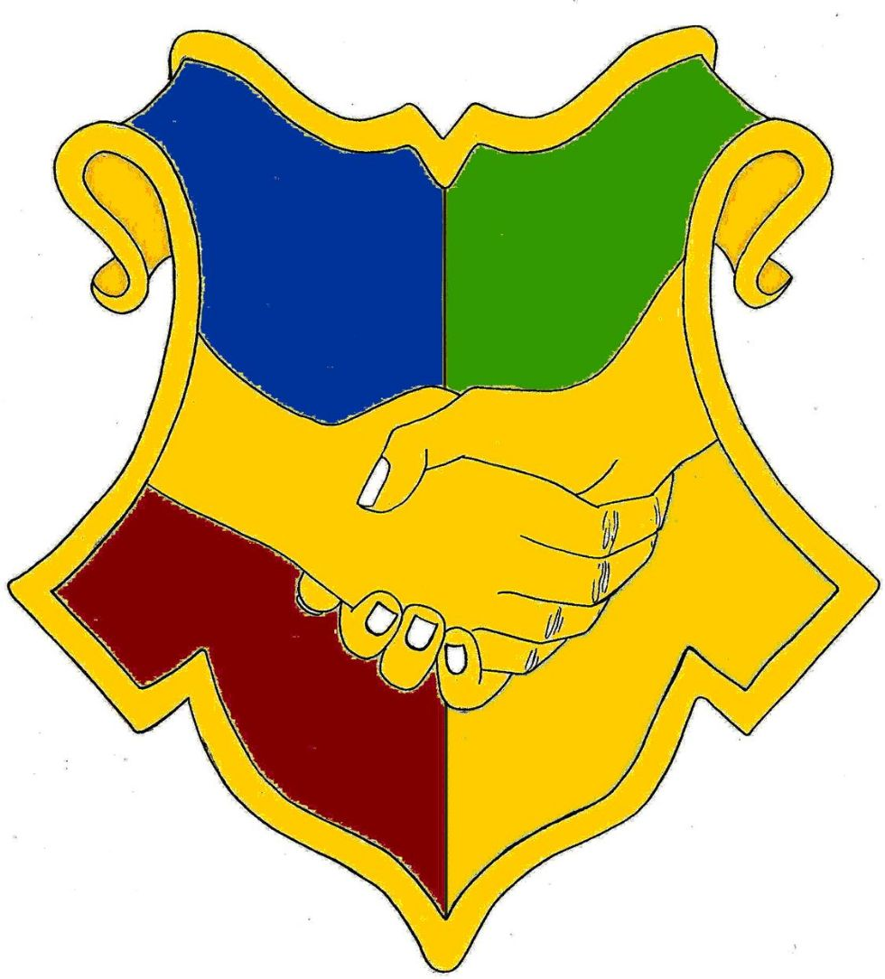
Reception New Intake
Home Learning and Practice Journal

This journal belongs to: ……………………………………….

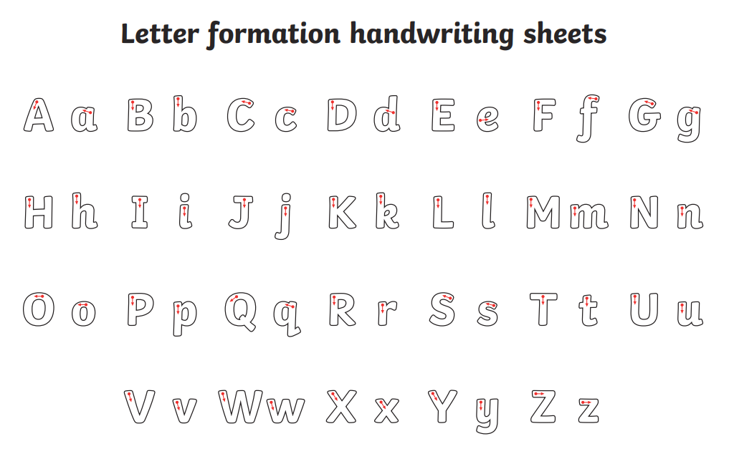
Phase 2- Little Wandle
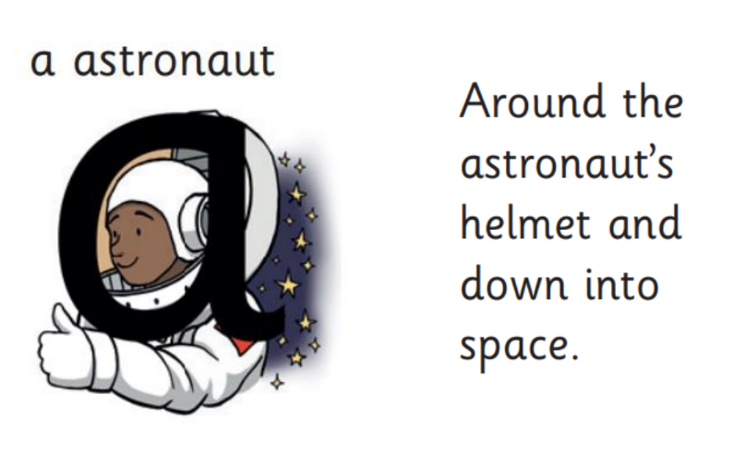
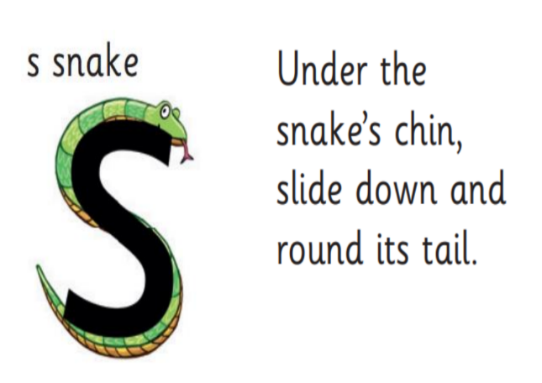
This is the first set of sounds we learn and they are in this order.

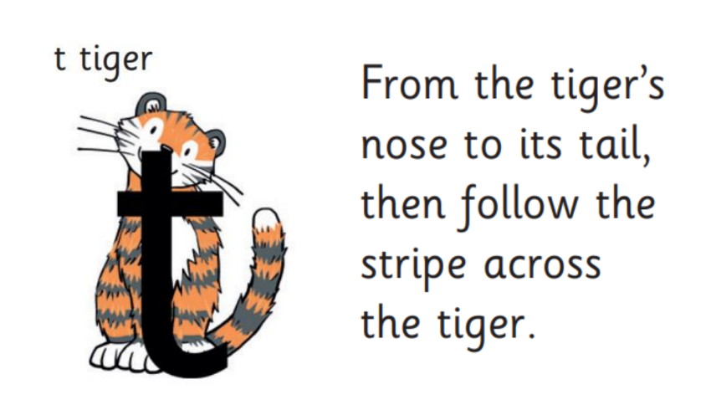
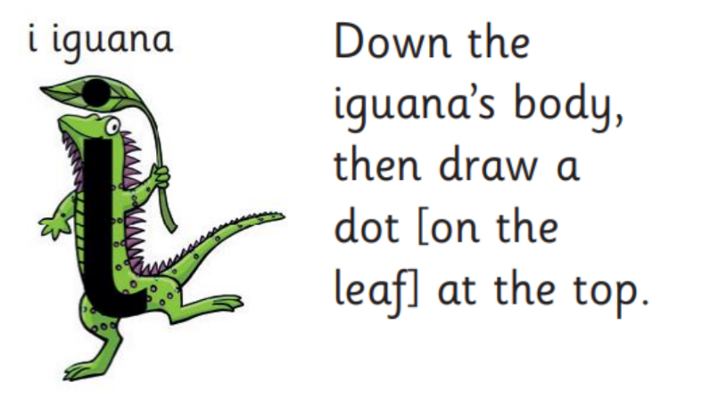
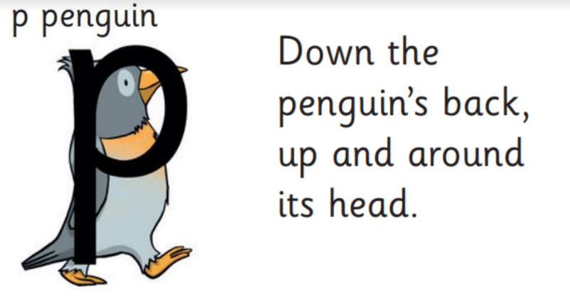
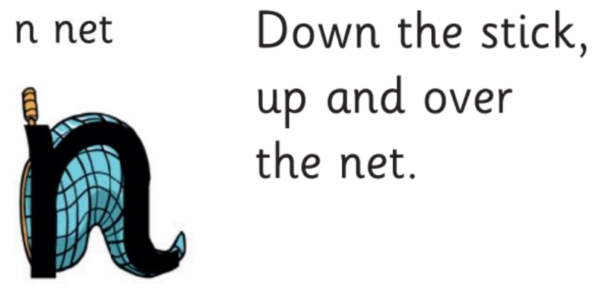

Can you read the first set of tricky words?
is
I
the

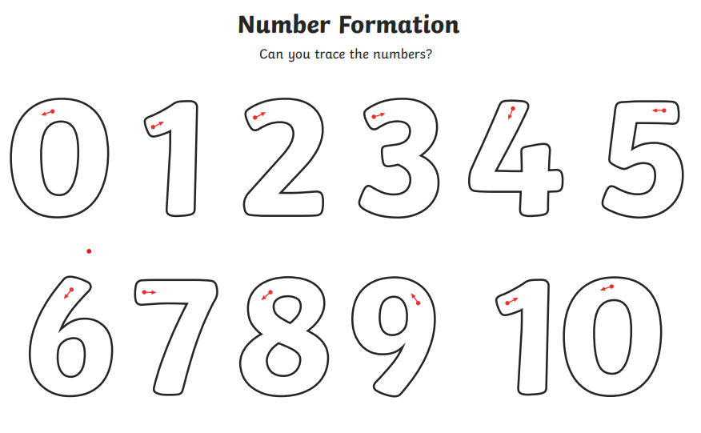
Can you find the number?
As an adult says a number out loud, can you find it on this page?
10 | 7 | 1
9 | 5 | 3
2 | 8 | 4
 | 6

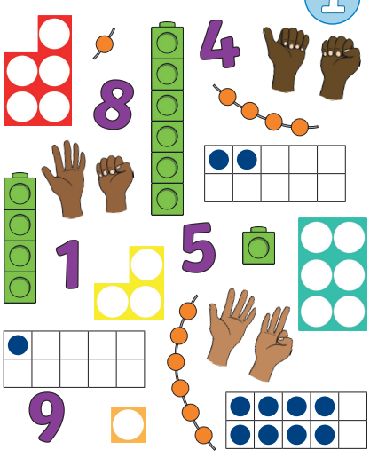
I spy- Which numbers can you see here?
Pre-Writing Shapes
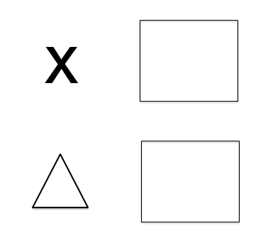
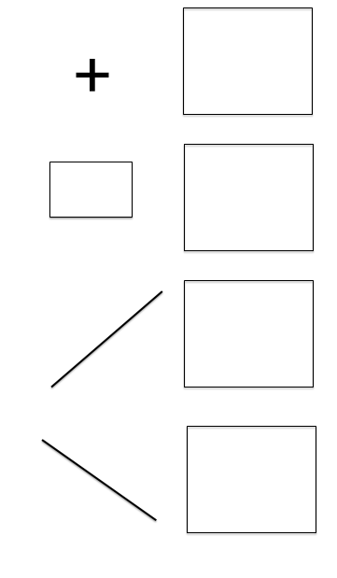
Before you can write- you need to be able to form these pre-writing shapes. Have a go at copying them.
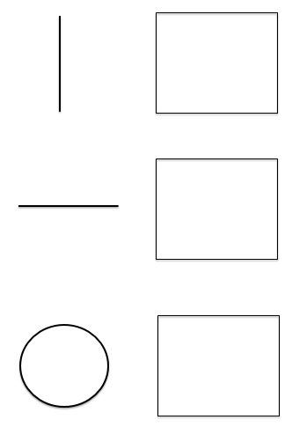

Can you talk about the shapes?

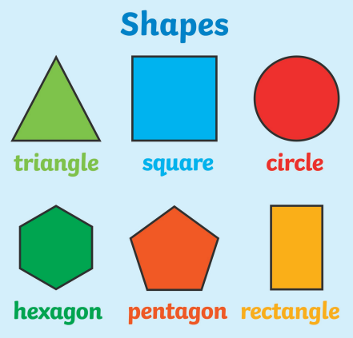
What are the names of the shapes?
What do you notice about them?
Writing your name
- I can recognise some of the letters in my name.
- When my name is written down, I can find my own name.
- I can form some letters of my name.
- I can write my name but some letters are not accurate.
- Yes! I can write my name.
- Repeat for your surname.

Have a practice at writing your name:

________________________________________________________________________________________________________________________________________________________________________________________________________________________________________________________________________________________________________________________________________________________________________________________________________
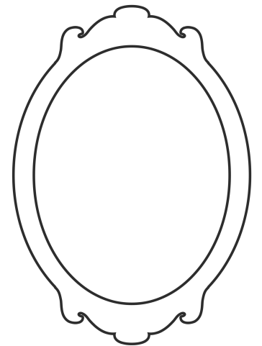
Can you draw a picture of yourself?
Can you draw a picture of your family?

Can you label who they are?
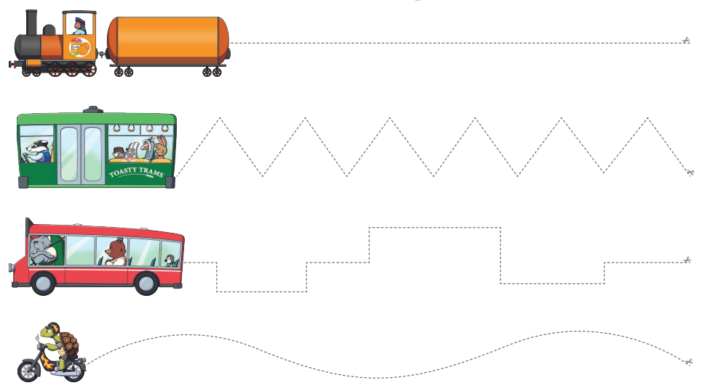
Can you practice cutting along the lines


