
Southfields Primary School Progression
Year 1

Autumn 1
 | Grammar, punctuation | Spelling | Genre skills | Handwriting
Week 1-3 | Spelling  Can use the suffix ‘s’ for plurals.  Use the -ed suffix at the end of words which do not need to be changed. | 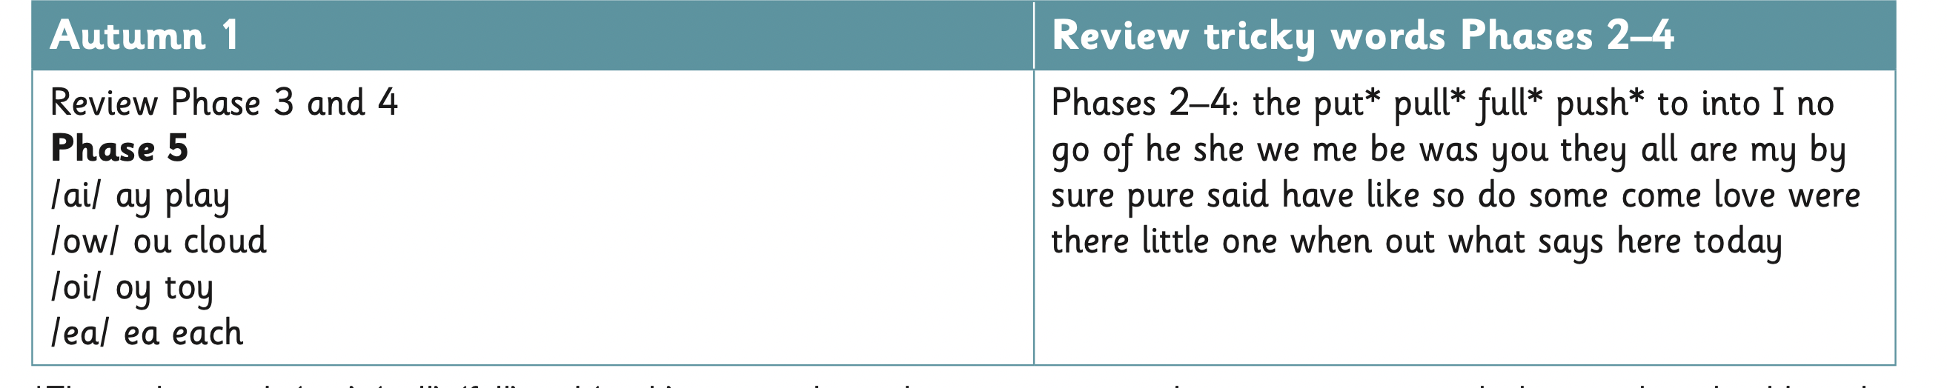  spelling:  words containing each of the 20+ phonemes already taught  25% of the common exception words  Monday, Tuesday  Can name a-g in the alphabet in order. | Narratives  To re-tell familiar stories and recount events; include main events in sequence, focusing on who is in the event, where events take place and what happens in each event;  To recite stories, supported by story boxes, pictures etc.; act out stories and portray characters and their motive. | To sit correctly at a table, holding a pencil comfortably and correctly.
Week 1-3 | Punctuation  Will be able to leave finger spaces between words.  Can use ‘and’ to join clauses.  Is beginning to use a capital letter and full stop correctly most the time.
Week 1-3 | Sentence construction  To orally compose a sentence before writing.
Week 4-7 | Spelling  Can use the suffix ‘s’ for plurals.  Use the -ed suffix at the end of words which do not  need to be changed. | Spelling:  words containing each of the 25+ phonemes already taught  30% of the common exception words  Monday, Tuesday, Wednesday  Can name a-g in the alphabet in order. | Letters  Understand and use the layout of a letter correctly. (Address, date, dear…, and sign off)  Punctuate sentences using full stops and capital letters.
Week 4-7 | Punctuation  Will be able to leave finger spaces between words.  Can use ‘and’ to join clauses.  Is beginning to use a capital letter and full stop correctly most the time.
Week 4-7 | Sentence construction  To be able to verbalise what the child will be writing about.  To orally compose a sentence before writing.

Autumn 2
 | Grammar, punctuation | Spelling | Genre skills | Handwriting
Week 1-3 | Spelling  Can use the suffix ‘s’ and ‘es’ for plurals.  Use the -ing and ed suffix at the end of words which do not need to be changed. | 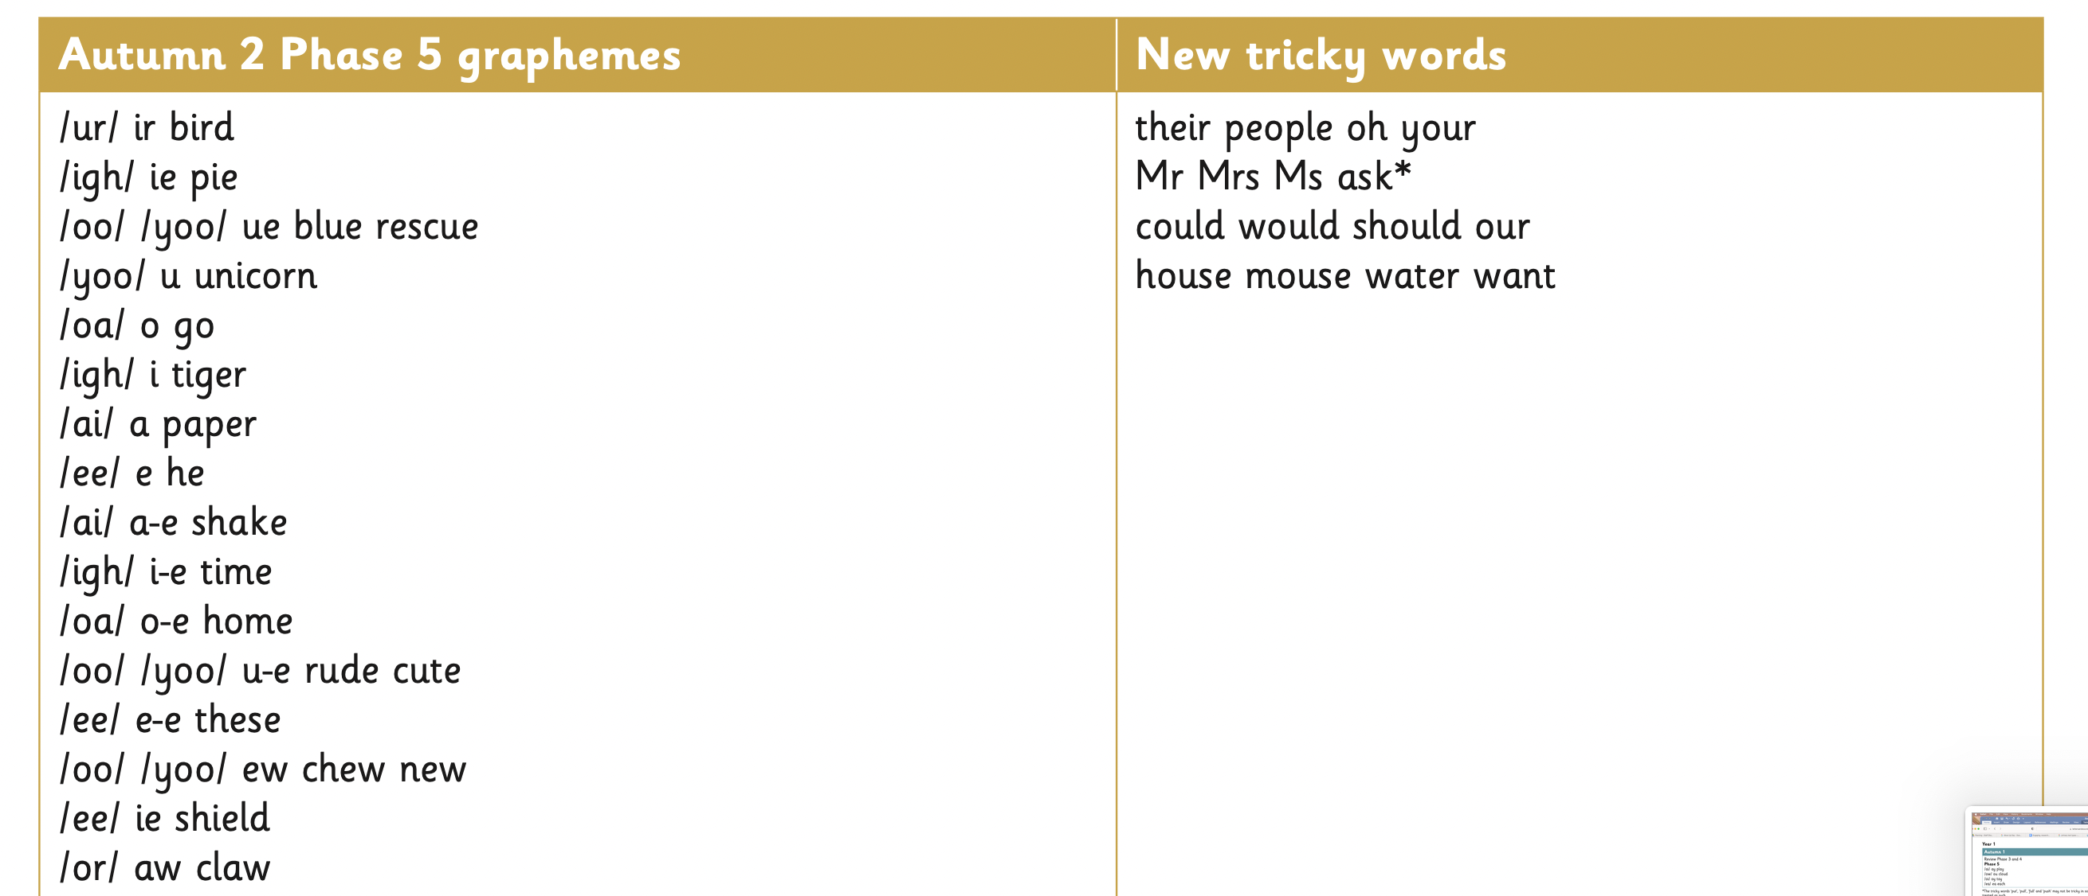  spelling:  words containing each of the 30+ phonemes already taught  35% of the common exception words  Monday, Tuesday, Wednesday, Thursday  Can name a-l in the alphabet in order. | Narratives  To re-tell familiar stories and recount events; include main events in sequence, focusing on who is in the event, where events take place and what happens in each event;  To use story language, sentence patterns and sequencing words to organise events, (e.g.) then, next etc.;  To recite stories, supported by story boxes, pictures etc.; act out stories and portray characters and their motive. | To form lower-case letters in the correct direction, starting and finishing in the right place
Week 1-3 | Punctuation  Will be able to leave finger spaces between words.  Can use ‘and’ to join clauses.  Is beginning to use a capital letter and full stop correctly most the time.  Can use the following grammatical terms: letter, capital letter, word, singular, plural. Sentence, punctuation, full stop, question mark, exclamation mark.
Week 1-3 | Sentence construction  To be able to verbalise what the child will be writing about.  To orally compose a sentence before writing.
Week 4-7 | Can use the suffix ‘s’ and ‘es’ for plurals.  Use the -ing and ed suffix at the end of words which do not need to be changed. | Spelling:  words containing each of the 35+ phonemes already taught  40% of the common exception words  Monday, Tuesday, Wednesday, Thursday  Can name a-l in the alphabet in order. | Instructions  Listen to and follow a single more detailed instruction and a longer series of instructions.  Think out and give clear single oral instructions.  Routinely read and follow written classroom labels carrying instructions.  Read and follow short series of instructions in shared context.  Contribute to class composition of instructions with teacher scribing.  Write three consecutive instructions independently.
Week 4-7 | Punctuation  Will be able to leave finger spaces between words.  Can use ‘and’ to join clauses.  Is beginning to use a capital letter and full stop correctly most the time.  Can use a question mark  Can use capital letters for: days of the week.  Can use the following grammatical terms: letter, capital letter, word, singular, plural. Sentence, punctuation, full stop, question mark, exclamation mark. |  | Poetry  To learn, reread and recite favourite poems, taking account of punctuation.  To comment on aspects such as word combinations, sound patterns (rhymes, rhythms, alliterative patterns) and forms of presentation.  To identify and discuss favourite poems and poets, using appropriate terms (poet, poem, verse, rhyme etc.) and referring to the language of the poem.  To use structures from poems as a basis for writing, by extending or substituting elements, inventing new lines, verses etc.  To discuss choice of words and phrases which describe and create impact (adjectives, verbs etc.).
Week 4-7 | Sentence construction  To be able to verbalise what the child will be writing about.  To orally compose a sentence before writing.  To start sequencing sentences to create a short narrative.

Spring 1
 | Grammar, punctuation | Spelling | Genre skills | Handwriting
Week 1-3 | Spelling  Can use the suffix ‘s’ and ‘es’ for plurals.  Use the -ing, -ed and -er suffix at the end of words which do not need to be changed.  Can use the prefix -un- | 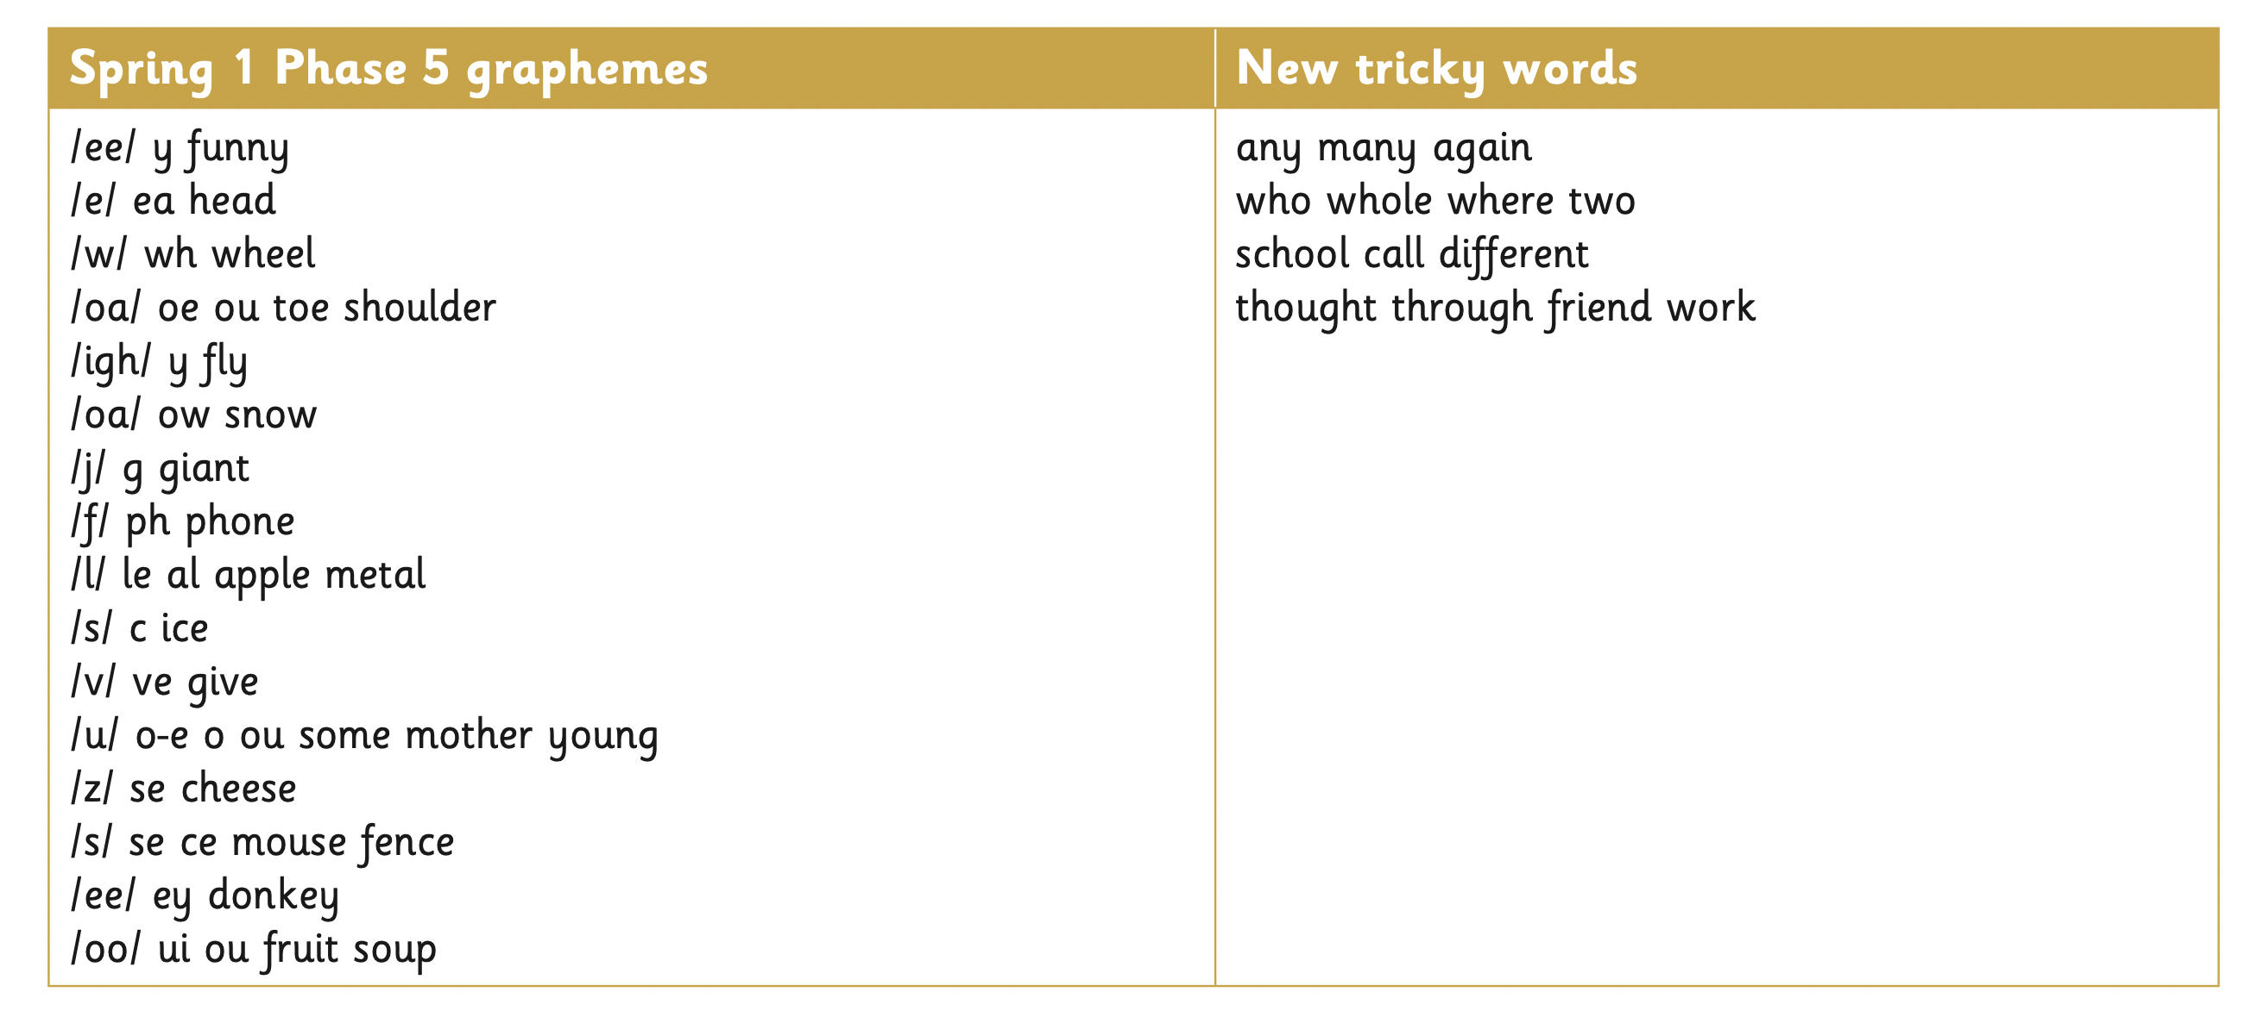  Spelling:  words containing each of the 30+ phonemes already taught  45% of the common exception words  Monday, Tuesday, Wednesday, Thursday, Friday  Can name a-q in the alphabet in order.  Can begin to use letter names to distinguish between alternative spellings of the same sound. | Narratives  To re-tell familiar stories and recount events; include main events in sequence, focusing on who is in the event, where events take place and what happens in each event;  To use story language, sentence patterns and sequencing words to organise events, (e.g.) then, next etc.;  To recite stories, supported by story boxes, pictures etc.; act out stories and portray characters and their motive. | To form lower-case letters in the correct direction, starting and finishing in the right place  To form capital letters correctly
Week 1-3 | Punctuation  Will be able to leave finger spaces between words.  Can use ‘and’ to join clauses.  Can use a capital letter and full stop correctly most the time half of the time  Can use a question mark  Can use capital letters for: days of the week.  Can use the following grammatical terms: letter, capital letter, word, singular, plural. Sentence, punctuation, full stop, question mark, exclamation mark.
Week 1-3 | Sentence construction  To be able to verbalise what the child will be writing about.  To orally compose a sentence before writing.  To start sequencing sentences to create a short narrative.
Week 4-7 | Spelling  Can use the suffix ‘s’ and ‘es’ for plurals.  Use the -ing, -ed and -er suffix at the end of words which do not need to be changed.  Can use the prefix -un- |  | Information text  Pose and orally rehearse questions ahead of writing and record these in writing, before reading.  Recognise that non-fiction books on similar themes can give different information and present similar information in different ways.  Write simple information texts incorporating labelled pictures and diagrams, charts, lists as appropriate.  Draw on knowledge and experience of texts in deciding and planning what and how to write.
Week 4-7 | Punctuation  Will be able to leave finger spaces between words.  Can use ‘and’ to join clauses.  Can use a capital letter and full stop correctly most the time.  Can use a question mark or exclamation mark.  Can use capital letters for: days of the week.  Can use the following grammatical terms: letter, capital letter, word, singular, plural. Sentence, punctuation, full stop, question mark, exclamation mark.
Week 4-7 | Sentence construction  To be able to verbalise what the child will be writing about.  To orally compose a sentence before writing.  To start sequencing sentences to create a short narrative.

Spring 2
 | Grammar, punctuation | Spelling | Genre skills | Handwriting
Week 1-3 | Can use the suffix ‘s’ and ‘es’ for plurals and third person verbs eg. runs.  Use the -ing, -ed, -er and -est suffix at the end of words which do not need to be changed.  Can use the prefix -un- | 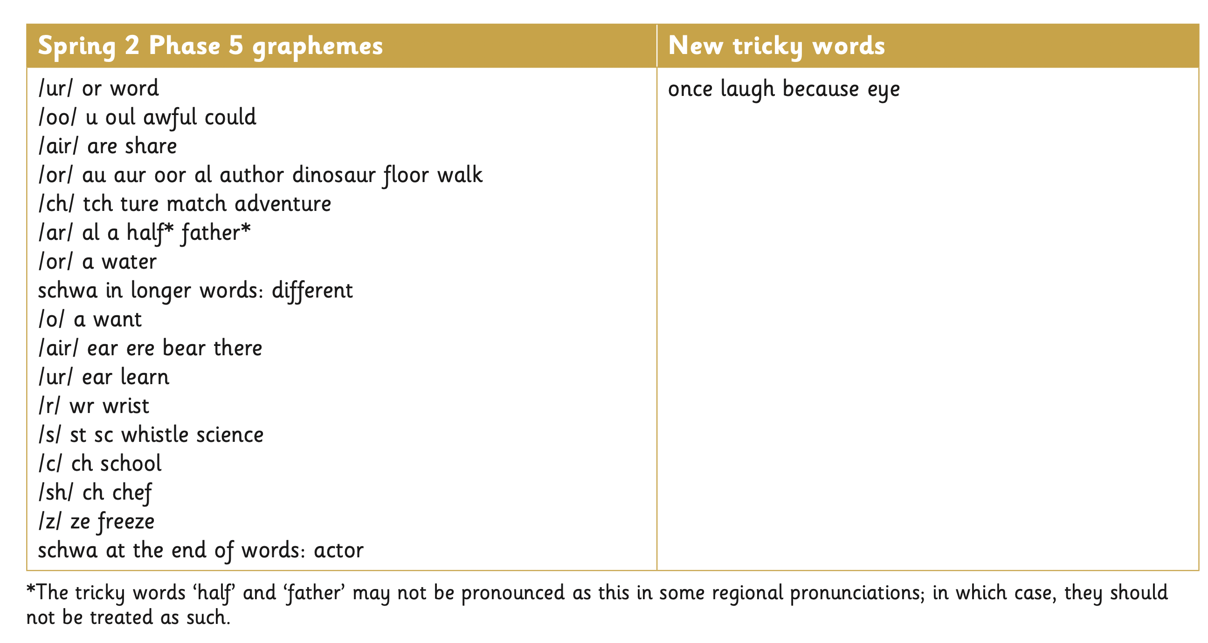  spelling:  words containing each of the 30+ phonemes already taught  55% of the common exception words  Monday, Tuesday, Wednesday, Thursday, Friday, Saturday.  Can name a-v in the alphabet in order.  Can begin to use letter names to distinguish between alternative spellings of the same sound. | Narratives  To re-tell familiar stories and recount events; include main events in sequence, focusing on who is in the event, where events take place and what happens in each event;  To use story language, sentence patterns and sequencing words to organise events, (e.g.) then, next etc.;  To recite stories, supported by story boxes, pictures etc.; act out stories and portray characters and their motive.  To use patterns and language from familiar stories in own writing; write complete stories with a simple structure: focusing on the beginning | To form lower-case letters in the correct direction, starting and finishing in the right place  To form capital letters and form digits 0-9
Week 1-3 | Punctuation  Will be able to leave finger spaces between words.  Can use ‘and’ to join clauses.  Can use a capital letter and full stop correctly most the time.  Can use a question mark or exclamation mark.  Can use capital letters for: names of people/places, days of the week.  Can use the following grammatical terms: letter, capital letter, word, singular, plural. Sentence, punctuation, full stop, question mark, exclamation mark. |  | Recounts  Describe incidents  from own experience in an audible voice using sequencing words and phrases such as ‘then’, ‘after that’; listen to other’s recounts and ask relevant questions.  Read personal recounts and begin to recognise generic structure, e.g. ordered sequence of events, use of words like first, next, after, when.
Week 1-3 | Sentence construction  To be able to verbalise what the child will be writing about.  To orally compose a sentence before writing.  To start sequencing sentences to create a short narrative.
Week 4-7 | Can use the suffix ‘s’ and ‘es’ for plurals and third person verbs eg. runs.  Use the -ing, -ed, -er and -est suffix at the end of words which do not need to be changed.  Can use the prefix -un- |  | Information text  Pose and orally rehearse questions ahead of writing and record these in writing, before reading.  Recognise that non-fiction books on similar themes can give different information and present similar information in different ways.  Write simple information texts incorporating labelled pictures and diagrams, charts, lists as appropriate.  Draw on knowledge and experience of texts in deciding and planning what and how to write.
Week 4-7 | Punctuation  Will be able to leave finger spaces between words.  Can use ‘and’ to join clauses.  Can use a capital letter and full stop correctly most the time.  Can use a question mark or exclamation mark.  Can use capital letters for: names of people/places, days of the week.  Can use the following grammatical terms: letter, capital letter, word, singular, plural. Sentence, punctuation, full stop, question mark, exclamation mark.
Week 4-7 | Sentence construction  To be able to verbalise what the child will be writing about.  To orally compose a sentence before writing.  To start sequencing sentences to create a short narrative.

Summer 1
 | Grammar, punctuation | Spelling | Genre skills | Handwriting
Week 1-3 | Spelling  Can use the suffix ‘s’ and ‘es’ for plurals and third person verbs eg. runs.  Use the -ing, -ed, -er and -est suffix at the end of words which do not need to be changed.  Can use the prefix -un-  To begin to write simple sentences dictated from the teacher. | Spelling:  words containing each of the 40+ phonemes already taught  60% of the common exception words  Monday, Tuesday, Wednesday, Thursday, Friday, Saturday, Sunday  Can name a-z in the alphabet in order.  Can use letter names to distinguish between alternative spellings of the same sound. | Narratives  To re-tell familiar stories and recount events; include main events in sequence, focusing on who is in the event, where events take place and what happens in each event;  To use story language, sentence patterns and sequencing words to organise events, (e.g.) then, next etc.;  To recite stories, supported by story boxes, pictures etc.; act out stories and portray characters and their motive.  To use patterns and language from familiar stories in own writing; write complete stories with a simple structure: beginning – middle – end, decide where it is set and use ideas from reading for some incidents and events. | To form lower-case letters in the correct direction, starting and finishing in the right place  To form capital letters  form digits 0-9  understand which letters belong to which handwriting ‘families’ (ie letters that are formed in similar ways) and to practise these
Week 1-3 | Punctuation  Will be able to leave finger spaces between words.  Can use ‘and’ to join clauses.  Can use a capital letter and full stop correctly most the time.  Can use a question mark or exclamation mark.  Can use capital letters for: names of people/places, days of the week.  Can use a capital letter for the pronoun I  Can use the following grammatical terms: letter, capital letter, word, singular, plural. Sentence, punctuation, full stop, question mark, exclamation mark. |  | Recounts  Describe incidents  from own experience in an audible voice using sequencing words and phrases such as ‘then’, ‘after that’; listen to other’s recounts and ask relevant questions.  Read personal recounts and begin to recognise generic structure, e.g. ordered sequence of events, use of words like first, next, after, when.  To include feelings about personal experience.
Week 1-3 | Sentence construction  To be able to verbalise what the child will be writing about.  To orally compose a sentence before writing.  To reread what they have written to ensure it makes sense.  To start sequencing sentences to create a short narrative.
Week 4-7 | Spelling  Can use the suffix ‘s’ and ‘es’ for plurals and third person verbs eg. runs.  Use the -ing, -ed, -er and -est suffix at the end of words which do not need to be changed.  Can use the prefix -un-  To begin to write simple sentences dictated from the teacher. |  | Letters  Understand and use the layout of a letter correctly. . (address, date, dear, and sign off)  Understand the purpose of the letter they are writing.  Understand who will be reading the letter and if the tone should be formal or informal.  Punctuate sentences using full stops and capital letters.  Use a variation of punctuation learnt such as question marks and exclamation marks.
Week 4-7 | Punctuation  Will be able to leave finger spaces between words.  Can use ‘and’ to join clauses.  Can use a capital letter and full stop correctly most the time.  Can use a question mark or exclamation mark.  Can use capital letters for: names of people/places, days of the week.  Can use a capital letter for the pronoun I  Can use the following grammatical terms: letter, capital letter, word, singular, plural. Sentence, punctuation, full stop, question mark, exclamation mark. |  | Invitations  Understand and use the layout of an invitation correctly.  Understand the content needed, for example, RSVP.  To choose words to persuade.
Week 4-7 | Sentence constuction  To be able to verbalise what the child will be writing about.  To orally compose a sentence before writing.  To reread what they have written to ensure it makes sense.  To start sequencing sentences to create a short narrative.

Summer 2
 | Grammar, punctuation | Spelling | Genre skills | Handwriting
Week 1-3 | Spelling  Can use the suffix ‘s’ and ‘es’ for plurals and third person verbs eg. runs.  Use the -ing, -ed, -er and -est suffix at the end of words which do not need to be changed.  Can use the prefix -un-  To write simple sentences dictated from the teacher. | 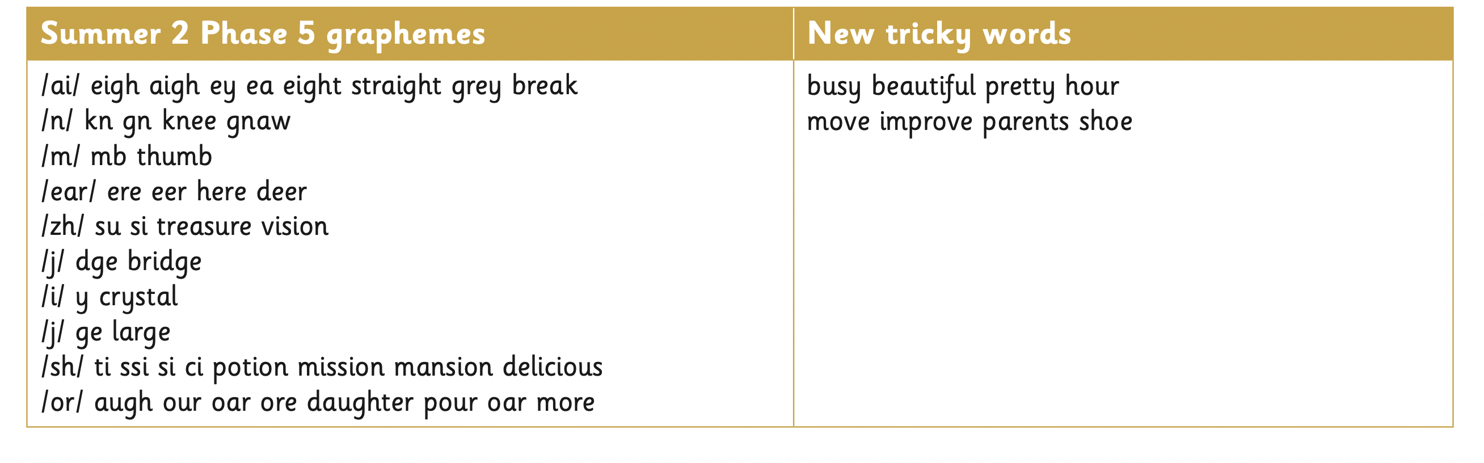:  Spelling:  words containing each of the 30+ phonemes already taught  75% of the common exception words  Monday, Tuesday, Wednesday, Thursday, Friday, Saturday, Sunday.  Can name a-z in the alphabet in order.  Can use letter names to distinguish between alternative spellings of the same sound. | Narratives  To re-tell familiar stories and recount events; include main events in sequence, focusing on who is in the event, where events take place and what happens in each event;  To use story language, sentence patterns and sequencing words to organise events, (e.g.) then, next etc.;  To recite stories, supported by story boxes, pictures etc.; act out stories and portray characters and their motive.  To use patterns and language from familiar stories in own writing; write complete stories with a simple structure: beginning – middle – end, decide where it is set and use ideas from reading for some incidents and events. | to form lower-case letters in the correct direction, starting and finishing in the right place  form capital letters  form digits 0-9  understand which letters belong to which handwriting ‘families’ (ie letters that are formed in similar ways) and to practise these
Week 1-3 | Punctuation  Will be able to leave finger spaces between words.  Can use ‘and’, but and so to join clauses.  Can use a capital letter and full stop correctly most the time.  Can use a question mark or exclamation mark.  Can use capital letters for: names of people/places, days of the week.  Can use a capital letter for the pronoun I  Can use the following grammatical terms: letter, capital letter, word, singular, plural. Sentence, punctuation, full stop, question mark, exclamation mark. |  | Letters  Understand and use the layout of a letter correctly.  Understand the purpose of the letter they are writing.  Understand who will be reading the letter and if the tone should be formal or informal.  Punctuate sentences using full stops and capital letters.  Use a variation of punctuation learnt such as question marks and exclamation marks.
Week 1-3 | Sentence construction  To be able to verbalise what the child will be writing about.  To orally compose a sentence before writing.  To reread what they have written to ensure it makes sense.  To start sequencing sentences to create a short narrative.
Week 4-7 | Spelling  Can use the suffix ‘s’ and ‘es’ for plurals and third person verbs eg. runs.  Use the -ing, -ed, -er and -est suffix at the end of words which do not need to be changed.  Can use the prefix -un-  To write simple sentences dictated from the teacher.
Week 4-7 | Punctuation  Will be able to leave finger spaces between words.  Can use ‘and’ to join clauses.  Can use a capital letter and full stop correctly most the time.  Can use a question mark or exclamation mark.  Can use capital letters for: names of people/places, days of the week.  Can use a capital letter for the pronoun I  Can use the following grammatical terms: letter, capital letter, word, singular, plural. Sentence, punctuation, full stop, question mark, exclamation mark.
Week 4-7 | Sentence construction  To be able to verbalise what the child will be writing about.  To orally compose a sentence before writing.  To reread what they have written to ensure it makes sense.  To start sequencing sentences to create a short narrative.

