
Southfields Primary School Progression
Year 6

Autumn 1
 | Grammar, punctuation | Spelling | Genre skills | Handwriting
Week 1-3 | Spelling  To spell 45% of the Year 5/6 Common Exception Words.  To use a variety of prefixes and suffixes.  To distinguish between homophones and words that are easily confused.  Secure knowledge of morphology and etymology.  Use a dictionary to spell and check the meaning of words.  To use a thesaurus. | 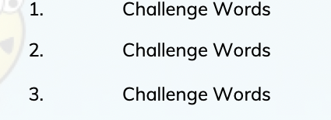 | Postcard  Understand and use level of formality correctly, for example, writing to a friend versus writing to a Member of Parliament. That is, having an awareness of the reader.  Understand and use the correct presentation for a letter, for example, Dear and from versus Yours Faithfully or Sincerely.  Create a relevant introduction.  Create a relevant summary or conclusion. | 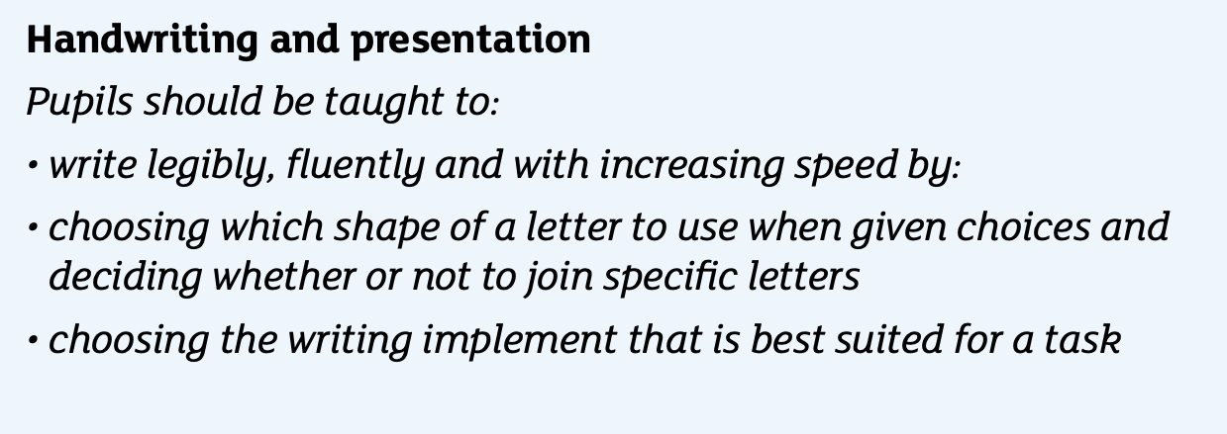
Week 1-3 | Punctuation  To use relative clauses and commas for clauses.  To use parenthesis punctuation correctly.  To concisely use noun phrases.  Use the perfect form verbs.  To introduce bullet points.  You use the correct grammatical structure for purpose.  To use the rules of double inverted commas for dialogue.  To use semi colons correctly
Week 1-3 | Sentence construction  To use dialogue to convey character.  To use a variety of cohesive devices across a paragraph and a text.  To understand purpose and write carefully considering the audience.  To choose the correct words and tone to reflect formality.  To precise longer passages.  Change vocabulary, punctuation and grammar to enhance effect.  Draw on research when required.
Week 4-7 | Spelling  To spell 50% of the Year 5/6 Common Exception Words.  To use a variety of prefixes and suffixes.  To distinguish between homophones and words that are easily confused.  Secure knowledge of morphology and etymology.  Use a dictionary to spell and check the meaning of words.  To use a thesaurus. | 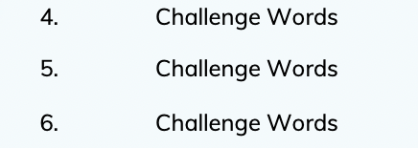 | Narrative  Identify story structures typical to particular fiction genres; recognise that narrative structure can be adapted and events revealed in different ways, (e.g.) stories within stories, flashbacks, revelations.  Analyse the paragraph structure in different types of story and note how links are made; make judgements in response to story endings, (e.g.) whether it was believable, whether dilemmas were resolved satisfactorily.  Look at elements of an author’s style to identify common elements and then make comparisons between books;  Consider how style is influenced by the time when they wrote and the intended audience;
Week 4-7 | Punctuation  To use relative clauses and commas for clauses.  To use parenthesis punctuation correctly.  To concisely use noun phrases.  Use the perfect form verbs.  To introduce bullet points.  You use the correct grammatical structure for purpose.  To use the rules of double inverted commas for dialogue.  To use semi colons correctly.
Week 4-7 | Sentence construction  To use dialogue to convey character.  To use a variety of cohesive devices across a paragraph and a text.  To understand purpose and write carefully considering the audience.  To choose the correct words and tone to reflect formality.  To precise longer passages.  Change vocabulary, punctuation and grammar to enhance effect.  Draw on research when required.

Autumn 2
 | Grammar, punctuation | Spelling | Genre skills | Handwriting
Week 1-3 | Spelling  To spell 55% of the Year 5/6 Common Exception Words.  To use a variety of prefixes and suffixes.  To distinguish between homophones and words that are easily confused.  Secure knowledge of morphology and etymology.  Use a dictionary to spell and check the meaning of words.  To use a thesaurus. | 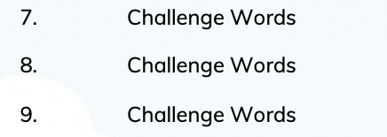 | Recount  Distinguish between biography and autobiography, recognising the effect on the reader of the choice between first and third person, distinguishing between fact, opinion and fiction, distinguishing between implicit and explicit points of view and how these can differ.  Develop the skills of biographical and autobiographical writing in role, adapting distinctive voices, e.g. of historical characters, through preparing a CV;  Composing a biographical account based on research or describing a person from different perspectives, e.g. police description, school report, newspaper obituary.  When planning writing, select the appropriate style and form to suit a specific purpose and audience, drawing on knowledge of different non-fiction text types.  Use the language conventions and grammatical features of the different types of text as appropriate.
Week 1-3 | Punctuation  To use relative clauses and commas for clauses.  To use parenthesis punctuation correctly.  To concisely use noun phrases.  Use the perfect form verbs.  To introduce bullet points.  You use the correct grammatical structure for purpose.  To use the rules of double inverted commas for dialogue.  To use semi colons correctly
Week 1-3 | Sentence construction  To use dialogue to convey character.  To use a variety of cohesive devices across a paragraph and a text.  To understand purpose and write carefully considering the audience.  To choose the correct words and tone to reflect formality.  To precise longer passages.  Change vocabulary, punctuation and grammar to enhance effect.  Draw on research when required. |  | Narrative  Identify story structures typical to particular fiction genres; recognise that narrative structure can be adapted and events revealed in different ways, (e.g.) stories within stories, flashbacks, revelations;  Analyse the paragraph structure in different types of story and note how links are made; make judgements in response to story endings, (e.g.) whether it was believable, whether dilemmas were resolved satisfactorily.  Look at elements of an author’s style to identify common elements and then make comparisons between books;  consider how style is influenced by the time when they wrote and the intended audience;
Week 4-7 | Spelling  To spell 55% of the Year 5/6 Common Exception Words.  To use a variety of prefixes and suffixes.  To distinguish between homophones and words that are easily confused.  Secure knowledge of morphology and etymology.  Use a dictionary to spell and check the meaning of words.  To use a thesaurus. | 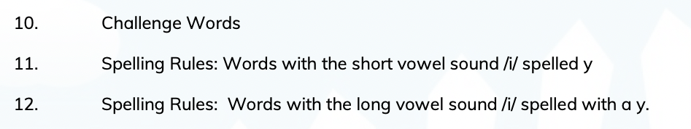
Week 4-7 | Punctuation  To use relative clauses and commas for clauses.  To use parenthesis punctuation correctly.  To concisely use noun phrases.  Use the perfect form verbs.  To introduce bullet points.  You use the correct grammatical structure for purpose.  To use the rules of double inverted commas for dialogue.  To use semi colons correctly
Week 4-7 | Sentence construction  To use dialogue to convey character.  To use a variety of cohesive devices across a paragraph and a text.  To understand purpose and write carefully considering the audience.  To choose the correct words and tone to reflect formality.  To precise longer passages.  Change vocabulary, punctuation and grammar to enhance effect.  Draw on research when required.

Spring 1
 | Grammar, punctuation | Spelling | Genre skills | Handwriting
Week 1-3 | Punctuation  To use relative clauses and commas for clauses.  To use parenthesis punctuation correctly.  To concisely use noun phrases.  Use the perfect form verbs.  To introduce bullet points.  You use the correct grammatical structure for purpose.  To use the rules of double inverted commas for dialogue.  To use colons and semi colons correctly | 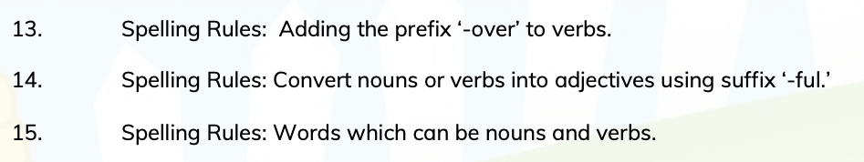  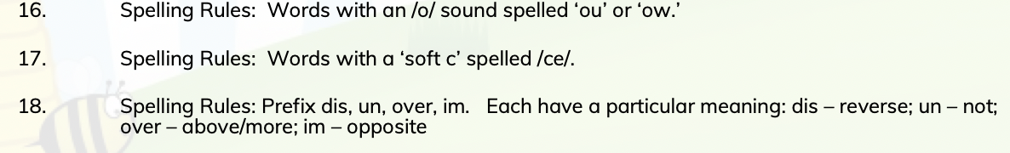 | Informal Letter writing  Understand and use level of formality correctly, for example, writing to a friend versus writing to a Member of Parliament. That is, having an awareness of the reader.  Understand and use the correct presentation for a letter, for example, Dear and from versus Yours Faithfully or Sincerely.  Create a relevant introduction.  Create a relevant summary or conclusion.
Week 1-3 | Sentence construction  To use dialogue to convey character.  To use a variety of cohesive devices across a paragraph and a text.  To understand purpose and write carefully considering the audience.  To choose the correct words and tone to reflect formality.  To precise longer passages.  Change vocabulary, punctuation and grammar to enhance effect.  Draw on research when required.
Week 4-7 | Spelling  To spell 65% of the Year 5/6 Common Exception Words.  To use a variety of prefixes and suffixes.  To distinguish between homophones and words that are easily confused.  Secure knowledge of morphology and etymology.  Use a dictionary to spell and check the meaning of words.  To use a thesaurus. |  | Non chronological report  Secure understanding of the form, language conventions and grammatical features of non  chronological reports.  Write reports as part of a presentation on a nonfiction subject.  Choose the appropriate style and form of writing to suit a specific purpose and audience, drawing on knowledge of different nonfiction text types.
Week 4-7 | Punctuation  To use relative clauses and commas for clauses.  To use parenthesis punctuation correctly.  To concisely use noun phrases.  Use the perfect form verbs.  To introduce bullet points.  You use the correct grammatical structure for purpose.  To use the rules of double inverted commas for dialogue.  To use colons and semi colons correctly |  | Biography  Distinguish between biography and autobiography, recognising the effect on the reader of the choice between first and third person.  Distinguish between fact, opinion and fiction,  Distinguish between implicit and explicit points of view and how these can differ.
Week 4-7 | Sentence construction  To use dialogue to convey character.  To use a variety of cohesive devices across a paragraph and a text.  To understand purpose and write carefully considering the audience.  To choose the correct words and tone to reflect formality.  To precise longer passages.  Change vocabulary, punctuation and grammar to enhance effect.  Draw on research when required. |  | Narrative  Identify story structures typical to particular fiction genres; recognise that narrative structure can be adapted and events revealed in different ways, (e.g.) stories within stories, flashbacks, revelations;  Analyse the paragraph structure in different types of story and note how links are made; make judgements in response to story endings, (e.g.) whether it was believable, whether dilemmas were resolved satisfactorily.  Look at elements of an author’s style to identify common elements and then make comparisons between books;  Consider how style is influenced by the time when they wrote and the intended audience;

Spring 2
 | Grammar, punctuation | Spelling | Genre skills | Handwriting
Week 1-3 | Spelling  To spell 70% of the Year 5/6 Common Exception Words.  To use a variety of prefixes and suffixes.  To distinguish between homophones and words that are easily confused.  Secure knowledge of morphology and etymology.  Use a dictionary to spell and check the meaning of words.  To use a thesaurus. | 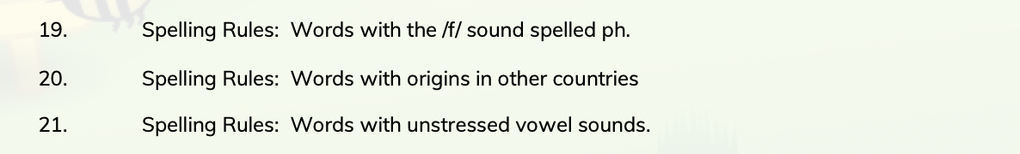  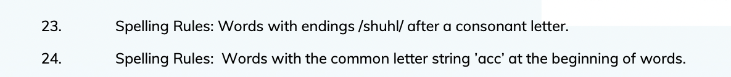 | Narrative  Identify story structures typical to particular fiction genres; recognise that narrative structure can be adapted and events revealed in different ways, (e.g.) stories within stories, flashbacks, revelations;  analyse the paragraph structure in different types of story and note how links are made; make judgements in response to story endings, (e.g.) whether it was believable, whether dilemmas were resolved satisfactorily.  Look at elements of an author’s style to identify common elements and then make comparisons between books;  consider how style is influenced by the time when they wrote and the intended audience;
Week 1-3 | Punctuation  To use relative clauses and commas for clauses.  To use parenthesis punctuation correctly.  To concisely use noun phrases.  Use the perfect form verbs.  To introduce bullet points.  You use the correct grammatical structure for purpose.  To use the rules of double inverted commas for dialogue.  To use colons, semi colons and hyphens correctly |  | Poetry  To understand the following terms and identify them in poems: verse, chorus, couplet, stanza, rhythm, rhyme and alliteration.  To describe how a poet does or does not use rhyme.  To produce polished poems through revisions.  To analyse and compare poetic style, use of forms and the themes of significant poets.  To respond to shades of meaning.  To explain and justify personal tastes; to consider the impacts of full rhymes, half rhymes, internal rhymes and other sound patterns.  To investigate and collect different examples of word play. To convey feelings, reflections or moods in a poem through the careful choice of words and phrases.  To write metaphors from original ideas or from similes.  To understand terms that describe different types of poems, e.g. ballad, sonnet, rap, elegy, narrative poem and identify typical features.  To discuss how linked poems relate to one another by themes, format and repetition, e.g. cycle of poems about the seasons.  To describe and evaluate the style of an individual poet.  To comment critically on the overall impact of a poem, showing how language and themes have been developed.  To write their own poems experimenting with active verbs and personification.  To recognise how poets manipulate words: for their quality of sound (rhythm, rhyme, assonance); for their connotations; for multiple layers of meaning; nonsense words and how meaning can be made of them; where the appeal lies.  To analyse how messages, moods, feelings and attitudes are conveyed in poetry.  To read and interpret poems in which meanings are implied or multi-layered.  To write a sequence of poems linked by theme or form, e.g. a haiku calendar.
Week 1-3 | Sentence construction  To use dialogue to convey character.  To use a variety of cohesive devices across a paragraph and a text.  To understand purpose and write carefully considering the audience.  To choose the correct words and tone to reflect formaility.  To precise longer passages.  Change vocabulary, punctuation and grammar to enhance effect.  Draw on research when required.
Week 4-7 | Spelling  To spell 75% of the Year 5/6 Common Exception Words.  To use a variety of prefixes and suffixes.  To distinguish between homophones and words that are easily confused.  Secure knowledge of morphology and etymology.  Use a dictionary to spell and check the meaning of words.  To use a thesaurus. |  | Letter  Understand and use level of formality correctly, for example, writing to a friend versus writing to a Member of Parliament. That is, having an awareness of the reader.  Understand and use the correct presentation for a letter, for example, Dear and from versus Yours Faithfully or Sincerely.  Create a relevant introduction.  Create a relevant summary or conclusion.
Week 4-7 | Punctuation  To use relative clauses and commas for clauses.  To use parenthesis punctuation correctly.  To concisely use noun phrases.  Use the perfect form verbs.  To introduce bullet points.  You use the correct grammatical structure for purpose.  To use the rules of double inverted commas for dialogue.  To use colons, semi colons and hyphens correctly |  | Poetry  To understand the following terms and identify them in poems: verse, chorus, couplet, stanza, rhythm, rhyme and alliteration.  To describe how a poet does or does not use rhyme.  To produce polished poems through revisions.  To analyse and compare poetic style, use of forms and the themes of significant poets.  To respond to shades of meaning.  To explain and justify personal tastes; to consider the impacts of full rhymes, half rhymes, internal rhymes and other sound patterns.  To investigate and collect different examples of word play.  To convey feelings, reflections or moods in a poem through the careful choice of words and phrases.  To write metaphors from original ideas or from similes.  To understand terms that describe different types of poems, e.g. ballad, sonnet, rap, elegy, narrative poem and identify typical features.  To discuss how linked poems relate to one another by themes, format and repetition, e.g. cycle of poems about the seasons.  To describe and evaluate the style of an individual poet.  To comment critically on the overall impact of a poem, showing how language and themes have been developed.  To write their own poems experimenting with active verbs and personification.  To recognise how poets manipulate words: for their quality of sound (rhythm, rhyme, assonance); for their connotations; for multiple layers of meaning; nonsense words and how meaning can be made of them; where the appeal lies.  To analyse how messages, moods, feelings and attitudes are conveyed in poetry.  To read and interpret poems in which meanings are implied or multi-layered.  To write a sequence of poems linked by theme or form, e.g. a haiku calendar.
Week 4-7 | Sentence construction  To use dialogue to convey character.  To use a variety of cohesive devices across a paragraph and a text.  To understand purpose and write carefully considering the audience.  To choose the correct words and tone to reflect formality.  To precise longer passages.  Change vocabulary, punctuation and grammar to enhance effect.  Draw on research when required.

Summer 1
 | Grammar, punctuation | Spelling | Genre skills | Handwriting
Week 1-3 | Spelling  To spell 80% of the Year 5/6 Common Exception Words.  To use a variety of prefixes and suffixes.  To distinguish between homophones and words that are easily confused.  Secure knowledge of morphology and etymology.  Use a dictionary to spell and check the meaning of words.  To use a thesaurus. | Week 1-3  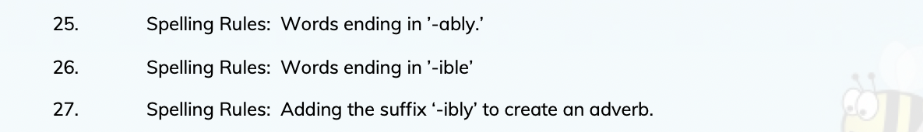  Week 4-7  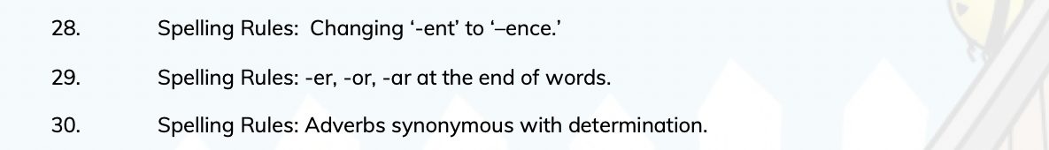 | Narrative  Identify story structures typical to particular fiction genres; recognise that narrative structure can be adapted and events revealed in different ways, (e.g.) stories within stories, flashbacks, revelations;  analyse the paragraph structure in different types of story and note how links are made; make judgements in response to story endings, (e.g.) whether it was believable, whether dilemmas were resolved satisfactorily.  Look at elements of an author’s style to identify common elements and then make comparisons between books;  consider how style is influenced by the time when they wrote and the intended audience; recognise that the narrator can change and be manipulated, (e.g.) a different character takes over the story-telling, the story has 2 narrators – talk about the effect that this has on the story and the reader’s response.
Week 1-3 | Punctuation  To use relative clauses and commas for clauses.  To use parenthesis punctuation correctly.  To concisely use noun phrases.  Use the perfect form verbs.  To introduce bullet points.  You use the correct grammatical structure for purpose.  To use the rules of double inverted commas for dialogue.  To use colons, semi colons and hyphens correctly |  | Poetry  Letters  Understand and use level of formality correctly, for example, writing to a friend versus writing to a Member of Parliament. That is, having an awareness of the reader.  Understand and use the correct presentation for a letter, for example, Dear and from versus Yours Faithfully or Sincerely.  Create a relevant introduction.  Create a relevant summary or conclusion.
Week 1-3 | Sentence construction  To use dialogue to convey character.  To use a variety of cohesive devices across a paragraph and a text.  To understand purpose and write carefully considering the audience.  To choose the correct words and tone to reflect formality.  To precise longer passages.  Change vocabulary, punctuation and grammar to enhance effect.  Draw on research when required.
Week 4-7 | Spelling  To spell 80% of the Year 5/6 Common Exception Words.  To use a variety of prefixes and suffixes.  To distinguish between homophones and words that are easily confused.  Secure knowledge of morphology and etymology.  Use a dictionary to spell and check the meaning of words.  To use a thesaurus.
Week 4-7 | Punctuation  To use relative clauses and commas for clauses.  To use parenthesis punctuation correctly.  To concisely use noun phrases.  Use the perfect form verbs.  To introduce bullet points.  You use the correct grammatical structure for purpose.  To use the rules of double inverted commas for dialogue.  To use colons, semi colons and hyphens correctly
Week 4-7 | Sentence construction  To use dialogue to convey character.  To use a variety of cohesive devices across a paragraph and a text.  To understand purpose and write carefully considering the audience.  To choose the correct words and tone to reflect formaility.  To precise longer passages.  Change vocabulary, punctuation and grammar to enhance effect.  Draw on research when required.

Summer 2
 | Grammar, punctuation | Spelling | Genre skills | Handwriting
Week 1-3 | Spelling  To spell 80% of the Year 5/6 Common Exception Words.  To use a variety of prefixes and suffixes.  To distinguish between homophones and words that are easily confused.  Secure knowledge of morphology and etymology.  Use a dictionary to spell and check the meaning of words.  To use a thesaurus. | Week 1-3  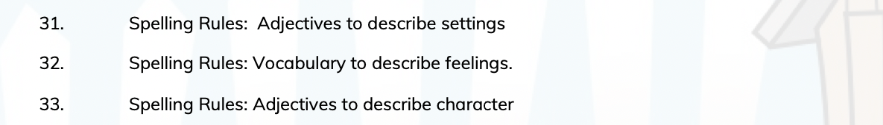 | Narrative  Identify story structures typical to particular fiction genres; recognise that narrative structure can be adapted and events revealed in different ways, (e.g.) stories within stories, flashbacks, revelations;  analyse the paragraph structure in different types of story and note how links are made; make judgements in response to story endings, (e.g.) whether it was believable, whether dilemmas were resolved satisfactorily.  Look at elements of an author’s style to identify common elements and then make comparisons between books;  consider how style is influenced by the time when they wrote and the intended audience; recognise that the narrator can change and be manipulated, (e.g.) a different character takes over the story-telling, the story has 2 narrators – talk about the effect that this has on the story and the reader’s response.
Week 1-3 | Punctuation  To use relative clauses and commas for clauses.  To use parenthesis punctuation correctly.  To concisely use noun phrases.  Use the perfect form verbs.  To introduce bullet points.  You use the correct grammatical structure for purpose.  To use the rules of double inverted commas for dialogue.  To use colons, semi colons abd hyohens correctly
Week 1-3 | Sentence construction  To use dialogue to convey character.  To use a variety of cohesive devices across a paragraph and a text.  To understand purpose and write carefully considering the audience.  To choose the correct words and tone to reflect formaility.  To precise longer passages.  Change vocabulary, punctuation and grammar to enhance effect.  Draw on research when required.
Week 4-7 | Spelling  Spelling  To spell 70% of the Year 5/6 Common Exception Words.  To use a variety of prefixes and suffixes.  To distinguish between homophones and words that are easily confused.  Secure knowledge of morphology and etymology.  Use a dictionary to spell and check the meaning of words.  To use a thesaurus. | Week 4-7  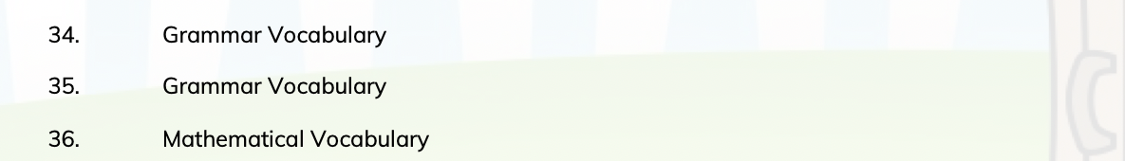
Week 4-7 | Punctuation  To use relative clauses and commas for clauses.  To use parenthesis punctuation correctly.  To concisely use noun phrases.  Use the perfect form verbs.  To introduce bullet points.  You use the correct grammatical structure for purpose.  To use the rules of double inverted commas for dialogue.  To use colons, semi colons and hyphens correctly
Week 4-7 | Sentence construction  To use dialogue to convey character.  To use a variety of cohesive devices across a paragraph and a text.  To understand purpose and write carefully considering the audience.  To choose the correct words and tone to reflect formality.  To precise longer passages.  Change vocabulary, punctuation and grammar to enhance effect.  Draw on research when required.

